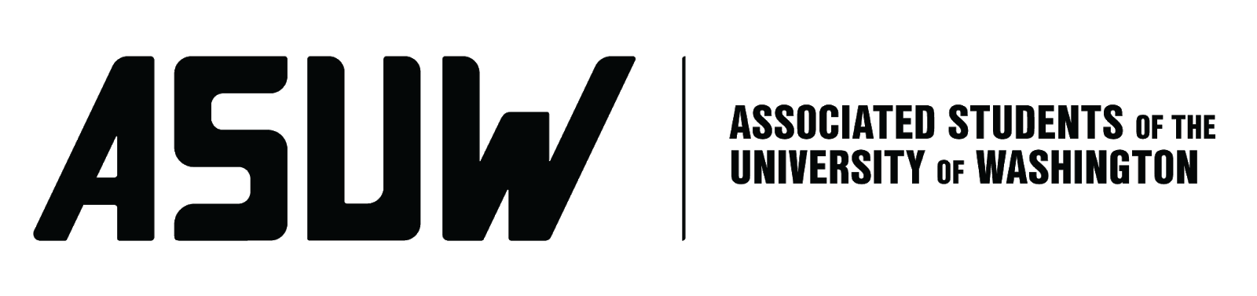
BOARD OF DIRECTORS
Session 121
Date October 14, 2021

Submitted by Christie Lee, Finance and Budget Director

BOARD BILL 3.04: An Act to Set the Fall Quarter 2021 Board of Directors Discretionary Fund Cap

WHEREAS: The ASUW Board of Directors sets a maximum annual amount from which they may spend using the ASUW General Fund, known as the Board Discretionary Fund; and

WHEREAS: This fund is typically used for costs associated with renting facilities, making copies, necessary travel, and other actions usually required for Board of Directors operations; and

WHEREAS: The feasibility of remote work is bound to change as the academic year continues, affecting the demand for funds; now

THEREFORE, BE IT ENACTED BY THE ASSOCIATED STUDENTS OF THE UNIVERSITY OF WASHINGTON BOARD OF DIRECTORS

THAT: The Autumn Quarter 2021 ASUW General Fund Spending Cap be set to $3,000; and

THAT: The Fund Cap for Winter Quarter 2022 and Spring Quarter 2022 will be determined at the start of each respective quarter; and

THAT: The Finance and Budget Director monitor the Board of Directors’ spending out of the General Fund; and
THAT: This bill be forwarded to Rene Singleton, SAO Advisor, and Christie Lee, Finance and Budget Director.

End

