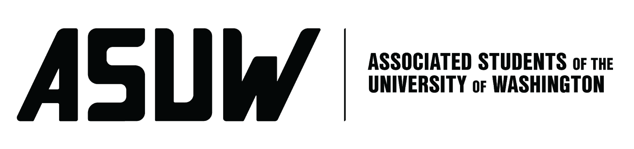
BOARD OF DIRECTORS
Session 121
Date October 14, 2021

Submitted by Micheal Saunders, Director Of Campus Partnerships

BOARD BILL 4.0: Partnership between ASUW & Sound Transit Fall Quarter 2021

Whereas;The Associated Students of the University of Washington is one the first student government and non-profit organizations in the State of Washington.

Whereas; ASUW provides services and programs to students from different backgrounds and participates in different functions of the university as the official student government.

Whereas; ASUW allows students to have the opportunity to have an influence in the “Shared Governance” which has three pillars; respectively dedicated to Administration, Faculty, and Students.

Whereas; ASUW is elated to allow students to communicate with more entities outside of the University of Washington that have great impacts on their daily lives like transportation services, policing services, and even food services in the area.

Whereas: The new light rail station in the U-District will have a great effect on the students of The University of Washington.

THEREFORE, BE IT ENACTED BY THE ASSOCIATED STUDENTS OF THE UNIVERSITY OF WASHINGTON BOARD OF DIRECTORS

THAT; The Associated Students of the University of Washington Board of Directors agree to partner with Sound Transit in the following way:
To allow engagement with the student body within the parameters of the HUB, North and South Lawns, Red Square, and The Quad.
- Tabling at events and during school hours
- Forums/ Q&As
- Surveys
- Events
- Posters/Marketing/etc
- Inclusion in Newsletters

THAT: Sound Transit agreed to further support students by donating $2,000 to Husky Pride Fund which is a fund that supports students in need of emergency financial assistance and is managed by The Director of Campus Partnerships.

THAT: The Sound Transit partnership will liaison through the Director of Campus Partnerships who will keep the Board informed of any and all decisions necessary.

THAT: This agreement is to be executed from the date of approval by the Board of Directors until 1 January 2022.

THAT; A copy of this bill be forwarded to Mustapha Samateh ASUW President, Michael Saunders- ASUW Director of Campus Partnerships, Justin Camputaro- HUB Executive Director, Rene Singleton ASUW Board Advisor, Nicole Phaysith - Sound-Transit Staff, Sandee Ditt- Sound Transit Fare & Engagement Manager.

